**Artificial Intelligence Project Report**

**Title** : Production System For 15 Puzzle

* Content:

|  |  |  |
| --- | --- | --- |
| S.No | Topics | Pg no |
| 1 | About | 2 |
| 2 | Methodology | 3 |
| 3 | Interactive or graphical results | 4 |
| 4 | Testing | 7 |
| 5 | Conclusion | 10 |

* About :

Production System:

A production system (or production rule system) is a computer program typically used to provide some form of artificial intelligence, which consists primarily of a set of rules about behavior but it also includes the mechanism necessary to follow those rules as the system responds to states of the world.

15-Puzzle Problem :

The 15 puzzle problem is invented by sam loyd in 1878. In this problem there are 15 tiles, which are numbered from 0 – 15. The objective of this problem is to transform the arrangement of tiles from initial arrangement to a goal arrangement. The initial and goal arrangement is shown by following figure.

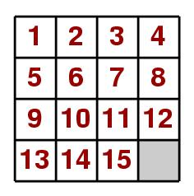

* Methodology :

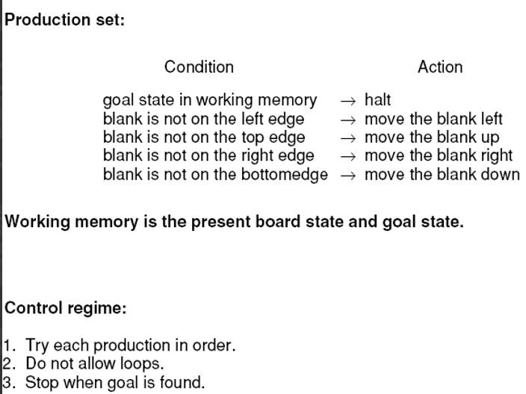

Branch and Bound method:

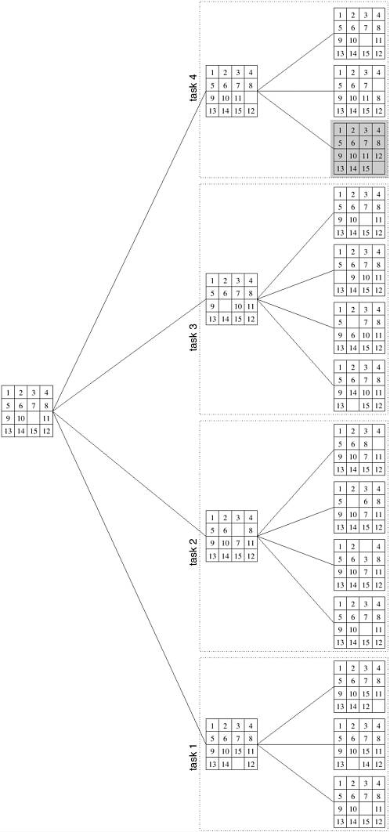

The first node is the initial state from which the next possible nodes are made. The highlighted node in the last row is the goal state which is to be reached by this process.

* Interactive or graphical results:

1. The recursive path algorithm as production system

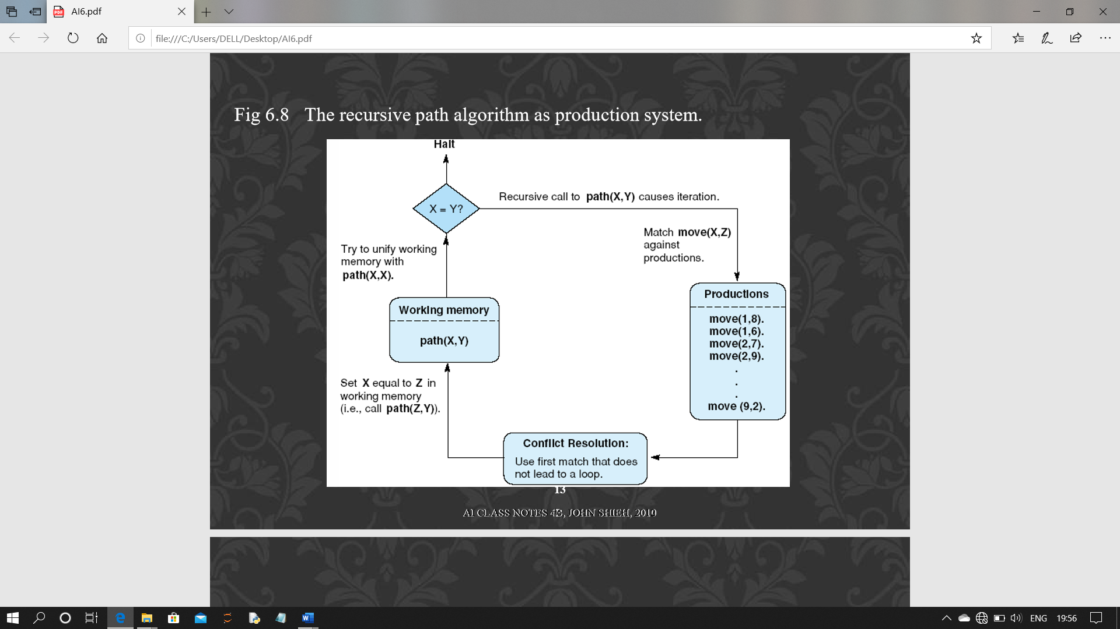

1. A production system working loop till the solution matches the memory pattern

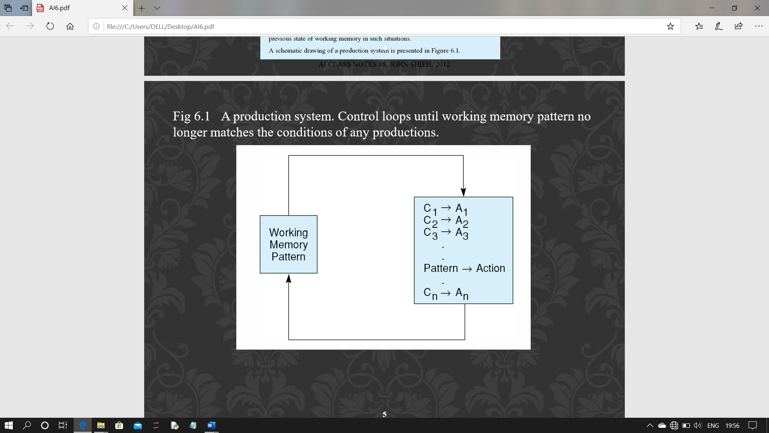

1. Trace of simple production system

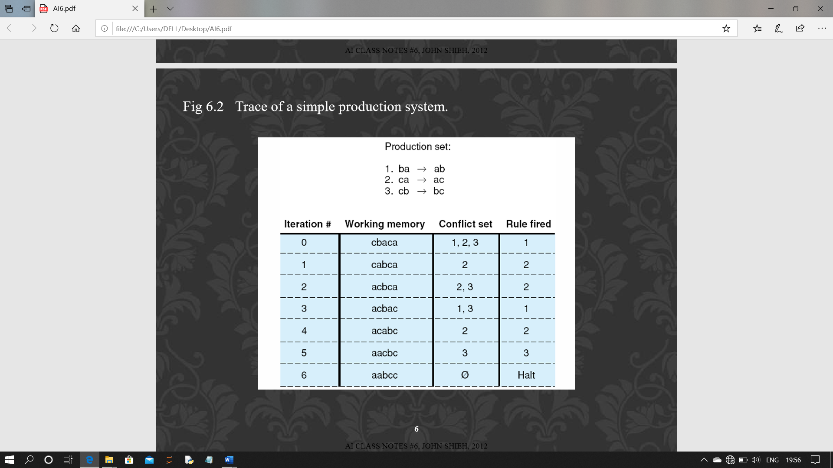

1. Data Driven Search in production System:

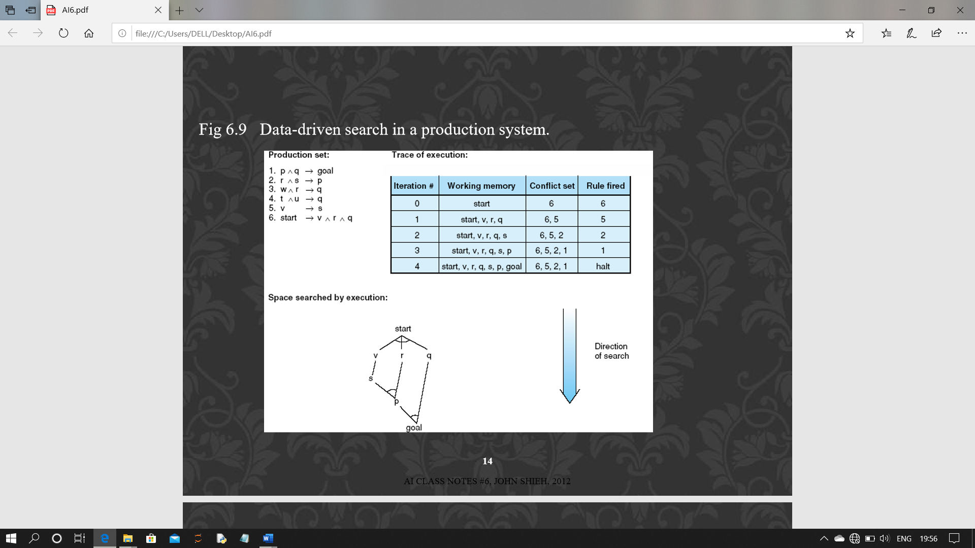

1. Goal Driven Search in production system:

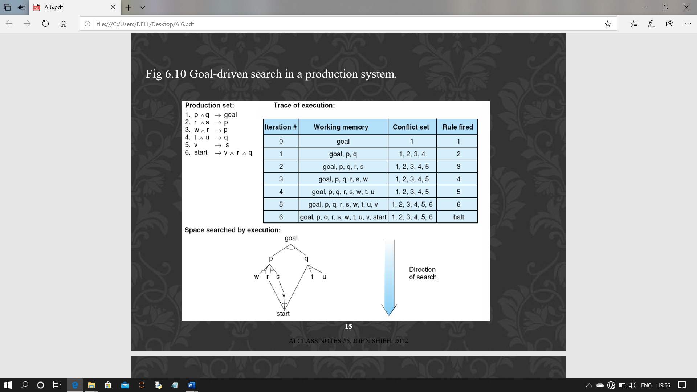

* Testing :

The below given algorithm and the function will help you reach the goal state from any initial state.

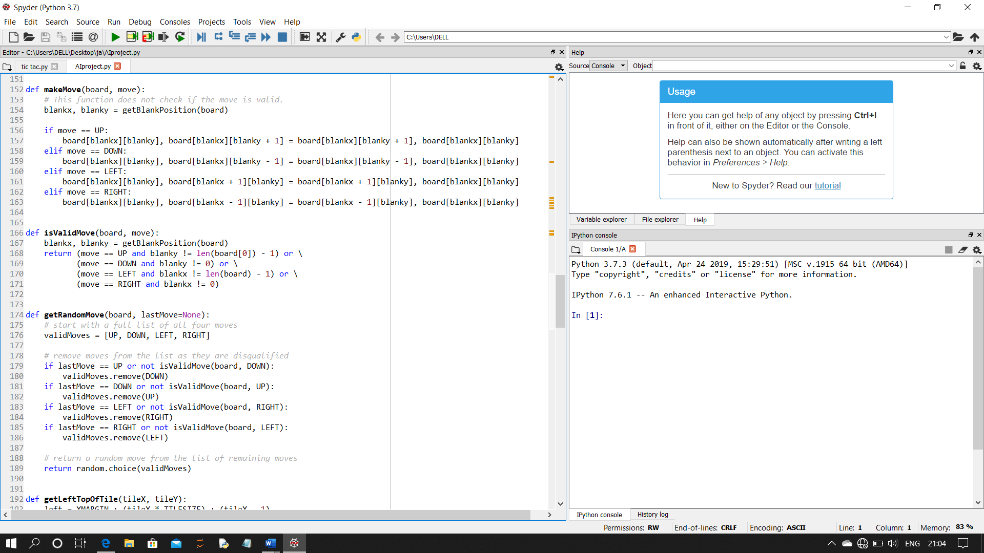

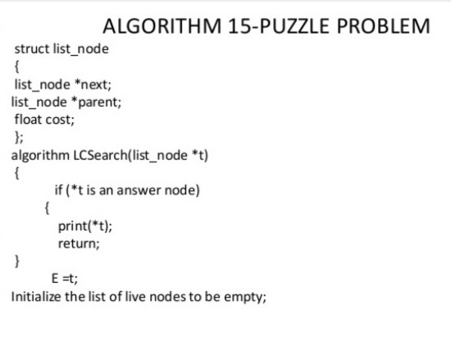

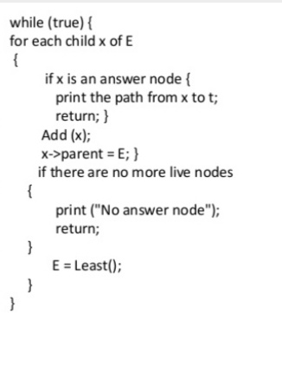

* Conclusion :

The final conclusion of this project that the working of the program is done by the algorithm and the functions perform the solution by the already stored memory which is one of the example the Production System process which uses different process like,

1. The recursive path algorithm
2. A production system working loop till the solution matches the memory pattern
3. Trace of simple production system
4. Data Driven Search
5. 5. Goal Driven Search

The functions and the algorithms also help in the completion of the problem.